**BST 5220 Multilevel and longitudinal study - HW6**

**Author: Miao Cai**

The data set was published in 1991 (*Semi-parametric and non-parametric methods for the analysis of repeated measurements with applications to clinical trials. Statistics in Medicine 10, 1959–1980.*) from a study on the impact of different doses of an anesthetic from 60 children. As soon as the children enter the anesthetic recovery room after a surgery their level of “awakeness” is measured followed by three further measurements after 5, 15 and 30 minutes (“time”). The level of “awakeness” is given on a spectrum ranging from 0 (sleeping) to 6 (awake). For each child the categorical influence variable “Dose” (dosage of the anesthetic; 15, 20, 25 or 30 mg/kg) as well as the metric influence variables “Age” (in months) and “Duration of the surgery” (in minutes) have been observed.

The data “**hw6p2_data**” is given on the blackboard.

You may want to re-code the time variable as 0, 1, 3 and 6.

**Questions:**

Treat the outcome variable as **ordinal,** use the Laplace estimation method to build a two-level logistic model for these data. Because all variables are of interest, they should be kept in the final model regardless of their statistical significance. Interpret significant effects.

[hw6_p2data.sas7bdat](https://blackboard.slu.edu/bbcswebdav/pid-3315623-dt-content-rid-15016551_1/xid-15016551_1)

**1. random-intercept only model**

/* Model 1: intercept-only model*/

**proc** **glimmix** data = HW6.hw6_p2data noclprint METHOD=laplace noclprint;

class ID;

model awake(desc) = / solution DIST=MULTINOMIAL LINK=CLOGIT;

random int /subject=ID type=un;

COVTEST / WALD;

**run**;

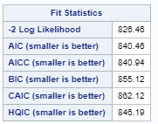 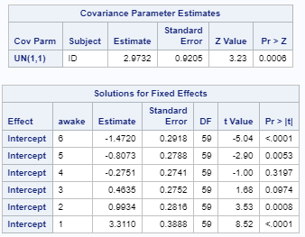

The level 2 variance is statistically significant, so the random intercept model makes sense.

**2. adding level 1 variables**

/* Model 2: adding level 1 variables - time*/

**proc** **glimmix** data = HW6.dat noclprint METHOD=laplace noclprint;

class ID;

model awake(desc) = time/ solution DIST=MULTINOMIAL LINK=CLOGIT;

random int /subject=ID type=un;

COVTEST / WALD;

**run**;

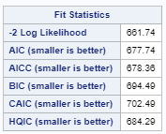 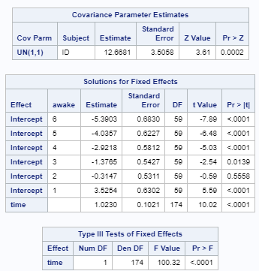

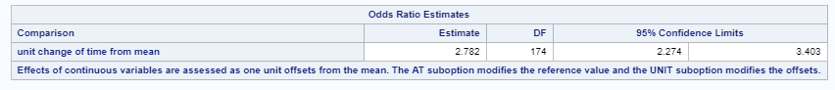 

The time variable and the deviance test was significant, so model 2 is significantly better than model1.

**Model 3: random slope of level 1 variables**

/* Model 3: random slope of level 1 variables - time*/

**proc** **glimmix** data = HW6.dat noclprint METHOD=laplace noclprint;

class ID;

model awake(desc) = time/ solution DIST=MULTINOMIAL LINK=CLOGIT oddsratio(LABEL);

random int time/subject=ID type=un;

COVTEST / WALD;

**run**;

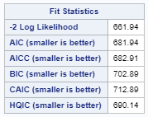 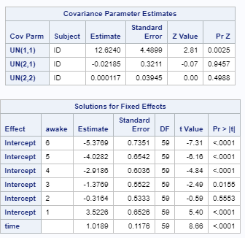

The level 2 variance of the time variable was not significant, nor does the interaction between level 1 and level 2 variance. The -2loglikelihood was increases. Therefore, the random slope model is no better than model 2.

Model 4: adding level 2 variables

/* Model 4: adding level 2 variables*/

**proc** **glimmix** data = HW6.dat noclprint METHOD=laplace noclprint noitprint;

class ID;

model awake(desc) = time dose age duration/ solution DIST=MULTINOMIAL LINK=CLOGIT oddsratio(LABEL);

random int/subject=ID type=un;

COVTEST / WALD;

**run**;

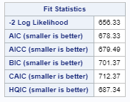 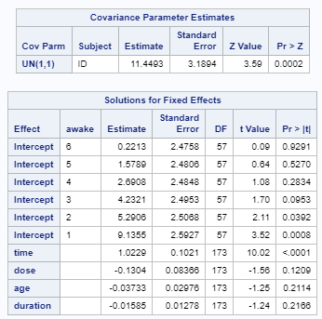 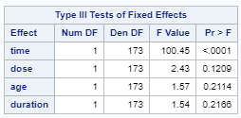  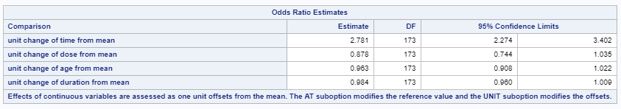

Although the added three variables were not significant and deviance test suggests that model 4 is no better than model 2, we still keep all three variables since they are of interest.

Interpretation:

Every five weeks go by, the children are 1.781 (95% confidence interval: [2.274, 3.402]) times more likely to have higher awake scores (1 -5).